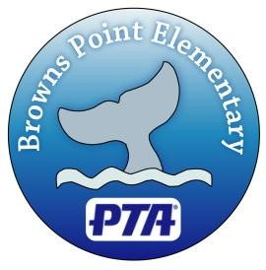
Browns Point Elementary PTA
1526 51st St. NE
Tacoma, WA 98422

Charitable Contribution Receipt

Date of receipt:______________
Donor:________________________________________________________________________
Type of contribution/donation:____________________________________________________
______________________________________________________________________________
Estimate of the value of goods or services: ___________________________________
The Browns Point PTA has not provided any goods or services in exchange for this contribution. Please retain this document for your records; it is an important document necessary for any available federal income tax deduction for this contribution.
The Browns Point PTA is a registered 501(c)(3) organization with the State of Washington. For matching funds purposes, our Tax I.D. Number is 91-1348878.

Authorized Signature: _______________________________________

Thank you for your donation!

